DSH - Foundations Course Handouts

**Table of Contents**

Chromebook Quick Set-Up Guide 3

Digital Skills Hub - Glossary of Terms 11

My Device Information Sheet 15

iPad Quick Set-Up Guide 16

[Learn about keyboard language and special characters](https://support.google.com/chromebook/answer/1059492)

[Learn about Chromebook accessibility features](https://support.google.com/chromebook/answer/177893)

# Chromebook Quick Set-Up Guide

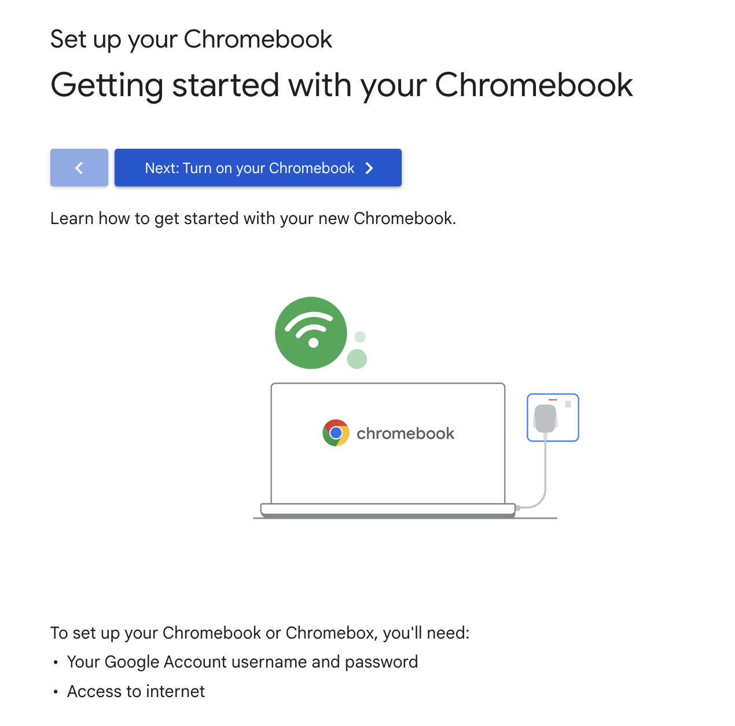











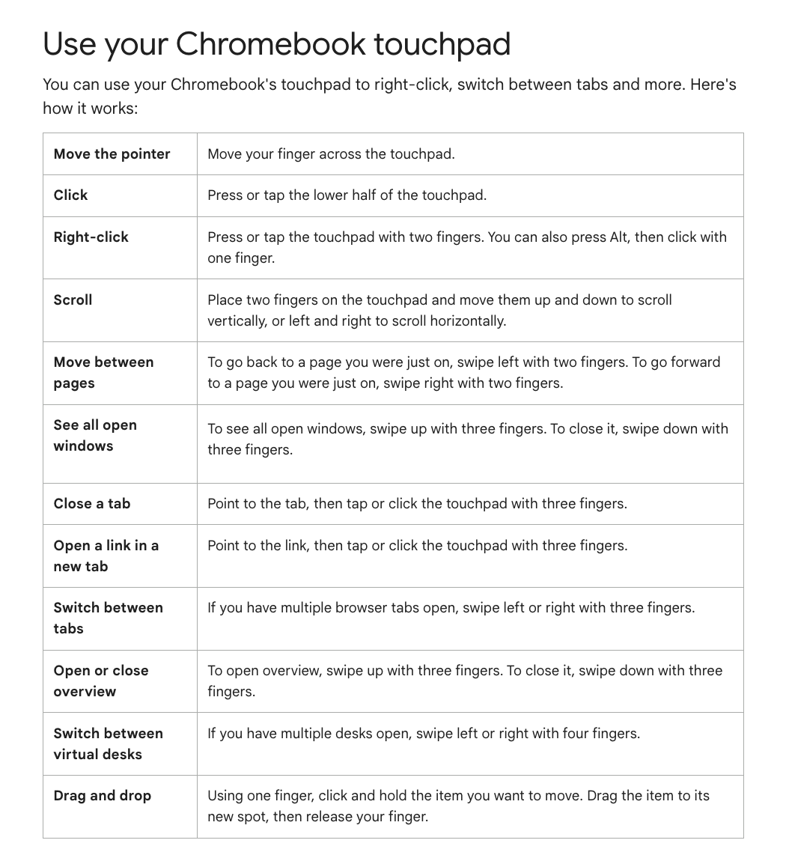



# Digital Skills Hub - Glossary of Terms

#### ***Organized by Topic***

#### **Devices**

**Laptop:** A portable computer that you can carry with you. It has a keyboard, screen, and battery, so you can use it without plugging it in. Example: Use a laptop to browse the internet or work on documents from anywhere.

**Tablet:** A small, flat device with a touchscreen, bigger than a phone but smaller than a laptop. You can use it to browse the internet, watch videos, or read books. Example: An iPad is a popular type of tablet.

**Chromebook:** A lightweight laptop that uses Google’s system and mostly works when connected to the internet. Example: You might use a Chromebook to practice typing or work on Google Docs.

**iPad:** A touchscreen tablet made by Apple. You can tap on the screen to open apps, watch videos, or take photos. Example: Use the iPad’s camera to take a photo or its browser to visit a website.

**Mouse:** A small handheld device used to move a pointer on the screen and click to select things. Example: Use the mouse to click on a button to open an email.

**Touchpad:** A flat surface on a laptop that you can touch with your fingers to move the pointer and click. Example: Drag your finger on the touchpad to scroll down a webpage.

#### **Using Devices**

**App (Application):** A program on your device that helps you do specific tasks, like taking photos, playing music, or browsing the web. Example: Chrome is an app you can use to browse the internet and access information.

**File:** A saved piece of work or media, like a document, photo, or video. Example: A Google Document or a family photo saved on your device is a file.

**Folder:** A digital space where you can organize files. Example: Create a folder called “Family Photos” to save all your pictures in one place.

**Click:** Pressing a button on a mouse or tapping on a screen to select something. Example: Click on the “Send” button to email someone.

**Tap:** Gently touching a screen to select or open something. Example: Tap on the YouTube app to watch a video.

**Scroll:** Moving up, down, or sideways on a screen to see more content. Example: Use your finger to scroll through your Facebook feed.

**Download:** To save something from the internet to your device. Example: You can download a photo from an email to your phone.

**Upload:** To send a file from your device to the internet. Example: Upload a picture to your Facebook account.

#### **Internet Basics**

**Internet:** A global network of computers and devices that allows you to access information, watch videos, and communicate with others. Example: When you use Google to search for something, you're using the internet.

**Wi-Fi:** A wireless network that lets you connect to the internet. Example: If you're at home, you might connect your device to your home Wi-Fi to browse the web.

**Website:** A place on the internet where you can find specific information or services. Example: Facebook is a website where you can connect with friends.

**Web Browser:** A program that lets you look at websites. Common browsers include Google Chrome, Safari, or Microsoft Edge. Example: You can use Chrome to visit a website like YouTube or check your email.

**Search Engine:** A tool that helps you find information on the internet. Example: Google is a search engine. If you type "weather tomorrow," it will show you tomorrow's forecast.

**URL (Uniform Resource Locator):** The web address that tells your browser where to find a specific website or file on the internet and it usually starts with "http://" or "https://". Example: https://www.google.com takes you to Google’s search engine.

**Hyperlink:** A clickable element—usually text or an image—that takes you to another website, document, or a different part of the same page when clicked. Hyperlinks often appear as blue, underlined text but can also be buttons or images.

#### **Email and Communication**

**Email:** A digital way to send messages, documents, or photos to others. Example: To send an email, you need an address like **yourname@gmail.com**.

**Gmail:** A free email service provided by Google. Example: Use Gmail to send a message to a friend or share a document with your teacher.

**Attachment:** A file (like a photo, video, or document) that you send with an email. Example: You can attach a picture of your pet to an email and send it to a friend.

**Username:** A unique name you create to log into an account. Example: Your username might be **janedoe123**.

**Password:** A secret word or combination of letters, numbers, and symbols to keep your accounts secure. Example: A strong password is something like **MyDog!2024**.

#### **Google Apps**

**Google Apps:** A set of free tools provided by Google to help you work, organize, and communicate. You need a Google Account (like Gmail) to access these tools, which can be used on a computer, tablet, or smartphone through the internet.

**Google Drive:** An online storage space where you can save files like documents, photos, and videos and access them from anywhere without needing a USB drive. Example: Save a resume or a family photo to Google Drive to access it later on any internet-connected device.

**Google Docs:** An app for creating and editing documents, like a digital notebook or Word processor. Example: Use it to type up a story or make a shopping list.

* Key Features:
  + **Text Formatting:** Bold, italic, or underline text.
  + **Comments:** Add suggestions or notes on the side.
  + **Sharing:** Allow others to view, comment, or edit.

**Google Slides:** An app to create presentations with text, pictures, and slides. Example: You can use Google Slides to create a slideshow for a family reunion.

* Key Features:
  + **Slides:** Pages of your presentation.
  + **Text Boxes:** Spaces to add words.
  + **Themes:** Pre-designed layouts to make your slides look polished.

**Google Sheets:** An app for organizing information in rows and columns, like a table. Example: Track your expenses in Google Sheets.

* Key Features:
  + **Cells:** Boxes to type in.
  + **Rows and Columns:** Rows go across; columns go up and down.
  + **Sorting:** Organize information alphabetically or numerically.

#### **Digital Safety and Security**

**Privacy:** Protecting your personal information (like your address, phone number, or password) online. Example: Don’t share your passwords or private details with people you don’t know.

**Cybersecurity:** Measures you take to stay safe online, like avoiding suspicious links or updating your device regularly. Example: If you get an email that looks strange, don’t click on the link.

#### 

#### **Social Media**

**Social Media:** Websites or apps where people share photos, messages, or videos, like Facebook, Instagram, or TikTok. Example: Use Facebook to share updates or connect with family.

**Post:** A message, photo, or video you share on social media.

**Comment:** A reply to a post on social media.

**Like:** Clicking a button to show you enjoy someone’s post or photo.

# Digital Skills Hub - Glossary of Terms

#### ***Organized Alphabetically***

**App (Application):** A program on your device that helps you do specific tasks, like taking photos, playing music, or browsing the web. Example: Chrome is an app you can use to browse the internet and access information.

**Attachment:** A file (like a photo, video, or document) that you send with an email. Example: You can attach a picture of your pet to an email and send it to a friend.

**Chromebook:** A lightweight laptop that uses Google’s system and mostly works when connected to the internet. Example: You might use a Chromebook to practice typing or work on Google Docs.

**Click:** Pressing a button on a mouse or tapping on a screen to select something. Example: Click on the “Send” button to email someone.

**Cybersecurity:** Measures you take to stay safe online, like avoiding suspicious links or updating your device regularly. Example: If you get an email that looks strange, don’t click on the link.

**Download:** To save something from the internet to your device. Example: You can download a photo from an email to your phone.

**Email:** A digital way to send messages, documents, or photos to others. Example: To send an email, you need an address like **yourname@gmail.com**.

**File:** A saved piece of work or media, like a document, photo, or video. Example: A Google Document or a family photo saved on your device is a file.

**Folder:** A digital space where you can organize files. Example: Create a folder called “Family Photos” to save all your pictures in one place.

**Gmail:** A free email service provided by Google. Example: Use Gmail to send a message to a friend or share a document with your teacher.

**Google Apps:** A set of free tools provided by Google to help you work, organize, and communicate. You need a Google Account (like Gmail) to access these tools, which can be used on a computer, tablet, or smartphone through the internet.

**Google Drive:** An online storage space where you can save files like documents, photos, and videos and access them from anywhere without needing a USB drive. Example: Save a resume or a family photo to Google Drive to access it later on any internet-connected device.

**Google Docs:** An app for creating and editing documents, like a digital notebook or Word processor. Example: Use it to type up a story or make a shopping list.

* Key Features:
  + **Text Formatting:** Bold, italic, or underline text.
  + **Comments:** Add suggestions or notes on the side.
  + **Sharing:** Allow others to view, comment, or edit.

**Google Sheets:** An app for organizing information in rows and columns, like a table. Example: Track your expenses in Google Sheets.

* Key Features:
  + **Cells:** Boxes to type in.
  + **Rows and Columns:** Rows go across; columns go up and down.
  + **Sorting:** Organize information alphabetically or numerically.

**Google Slides:** An app to create presentations with text, pictures, and slides. Example: You can use Google Slides to create a slideshow for a family reunion.

* Key Features:
  + **Slides:** Pages of your presentation.
  + **Text Boxes:** Spaces to add words.
  + **Themes:** Pre-designed layouts to make your slides look polished.

**Hyperlink:** A clickable element—usually text or an image—that takes you to another website, document, or a different part of the same page when clicked. Hyperlinks often appear as blue, underlined text but can also be buttons or images.

**Internet:** A global network of computers and devices that allows you to access information, watch videos, and communicate with others. Example: When you use Google to search for something, you're using the internet.

**iPad:** A touchscreen tablet made by Apple. You can tap on the screen to open apps, watch videos, or take photos. Example: Use the iPad’s camera to take a photo or its browser to visit a website.

**Laptop:** A portable computer that you can carry with you. It has a keyboard, screen, and battery, so you can use it without plugging it in. Example: Use a laptop to browse the internet or work on documents from anywhere.

**Mouse:** A small handheld device used to move a pointer on the screen and click to select things. Example: Use the mouse to click on a button to open an email.

**Password:** A secret word or combination of letters, numbers, and symbols to keep your accounts secure. Example: A strong password is something like **MyDog!2024**.

**Privacy:** Protecting your personal information (like your address, phone number, or password) online. Example: Don’t share your passwords or private details with people you don’t know.

**Scroll:** Moving up, down, or sideways on a screen to see more content. Example: Use your finger to scroll through your Facebook feed.

**Search Engine:** A tool that helps you find information on the internet. Example: Google is a search engine. If you type "weather tomorrow," it will show you tomorrow's forecast.

**Social Media:** Websites or apps where people share photos, messages, or videos, like Facebook, Instagram, or TikTok. Example: Use Facebook to share updates or connect with family. Other social media terms:

* **Post:** A message, photo, or video you share on social media.
* **Comment:** A reply to a post on social media.
* **Like:** Clicking a button to show you enjoy someone’s post or photo.

**Tablet:** A small, flat device with a touchscreen, bigger than a phone but smaller than a laptop. You can use it to browse the internet, watch videos, or read books. Example: An iPad is a popular type of tablet.

**Tap:** Gently touching a screen to select or open something. Example: Tap on the YouTube app to watch a video.

**Touchpad:** A flat surface on a laptop that you can touch with your fingers to move the pointer and click. Example: Drag your finger on the touchpad to scroll down a webpage.

**Upload:** To send a file from your device to the internet. Example: Upload a picture to your Facebook account.

**URL (Uniform Resource Locator):** The web address that tells your browser where to find a specific website or file on the internet and it usually starts with "http://" or "https://". Example: https://www.google.com takes you to Google’s search engine.

**Username:** A unique name you create to log into an account. Example: Your username might be **janedoe123**.

**Website:** A place on the internet where you can find specific information or services. Example: Facebook is a website where you can connect with friends.

**Web Browser:** A program that lets you look at websites. Common browsers include Google Chrome, Safari, or Microsoft Edge. Example: You can use Chrome to visit a website like YouTube or check your email.

**Wi-Fi:** A wireless network that lets you connect to the internet. Example: If you're at home, you might connect your device to your home Wi-Fi to browse the web.

# My Device Information Sheet

|  |  |
| --- | --- |
| **First Name:** |  |
| **Last Name:** |  |

|  |  |
| --- | --- |
| **Device Type:** |  |
| **Device Pin (if applicable):** |  |

**Google Account Information**

|  |  |
| --- | --- |
| **Username/E-mail:**  **E.g.,** flast@gmail.com |  |
| **Password:**  Must be 8 characters with an upper case and number |  |

**Apple ID Information (only for iPad)**

|  |  |
| --- | --- |
| **Username/E-mail:**  **E.g.,** flast@gmail.com |  |
| **Password:**  Must be 8 characters with an upper case and number |  |

# iPad Quick Set-Up Guide

