**Internet Resources**

Please note that the links for these Internet resources are not endorsements. They are sites to get you started on your Internet journey.

Columbus Based Community Resources

Entertainment

Financial Services

Health

Research and News

Shopping and eCommerce

Travel and Leisure

# Please note that the links for these Internet resources are not endorsements. They are sites to get your started on your Internet journey.

# **Columbus Based Community Resources**

| [Columbus Metropolitan Library](https://www.columbuslibrary.org/) | [Columbus Ohio Transit Authority](https://cota.com/) |
| --- | --- |
| [Educational Service Center of Central Ohio](https://www.escco.org/) | [Creative Housing/Creative Renovations](https://accessibilityrenovations.org/) |
| [Goodwill Columbus](https://www.goodwillcolumbus.org/services/for-individuals/?gclid=Cj0KCQjw06-oBhC6ARIsAGuzdw0tpArnhG5EaBZT8PcO9CgVNLfHm8k8xlrmyAdYN1gYbB85k9fgoUEaAhz_EALw_wcB) | [Franklin County Jobs and Family Services](https://communityportal.fcdjfs.franklincountyohio.gov/) |
| [Jewish Family Services](https://jfscolumbus.org/) | [Ohio Health](https://www.ohiohealth.com/) |
| [City of Columbus](https://new.columbus.gov/Home) | [Tech Corps](https://techcorps.org/) |
| [Catholic Social Services](https://colscss.org/) | [The Women’s Center for Economic Opportunity](https://www.womensceo.org/) |
| [Central Ohio Primary Care](https://www.copcp.com/) | [YWCA Columbus](https://www.ywcacolumbus.org/) |
| [Columbus Metropolitan Housing Authority](https://www.cmhanet.com/) |  |

# **Entertainment**

| [AARP Games](https://games.aarp.org/) | [Streaming Audio](https://edu.gcfglobal.org/en/using-the-web-to-get-stuff-done/streaming-music-services/1/) |
| --- | --- |
| [Comparing Streaming Services](https://www.allconnect.com/streaming) | [Streaming Video](https://edu.gcfglobal.org/en/using-the-web-to-get-stuff-done/streaming-video-services/1/) |
| [Entertainment Websites and Apps](https://techboomers.com/c/entertainment-websites-apps) | [YouTube](https://www.youtube.com/) |
| [Fun and Games](https://techboomers.com/c/fun-and-games-online) | [Wordle](https://www.nytimes.com/games/wordle/index.html) |

# **Financial Services**

| [Budget Pulse](https://www.budgetpulse.com/) | [Fifth Third Bank](https://www.53.com/content/fifth-third/en.html) |
| --- | --- |
| [Budget Simple](https://www.budgetsimple.com/) | [Financial Literacy](https://www.financialliteracy101.org/financial-literacy/index.cfm?) |
| [Chase Bank](https://www.chase.com/) | [Huntington Bank](https://www.huntington.com/) |
| [Digit](https://digit.co/) | [Money as You Grow](https://www.consumerfinance.gov/consumer-tools/money-as-you-grow/) |
| [Estate Planning](https://www.ncoa.org/adviser/estate-planning/estate-planning-guide-checklist/) | [Nationawide Bank](https://www.nationwide.com/) |
| [Free Credit Report](https://www.freecreditreport.com/homepage2?sc=678446&bcd=ad_c_sem_427_153150371928&k_id=41192bf8-bf31-4ec9-87ab-9f6d95a97c0e&k_kw=kwd-15077761&k_mt=e&pc=sem_fcr_google&cc=sem_fcr_google_ad_58595284_1833112804_153150371928_kwd-15077761_e_1t1_41192bf8-bf31-4ec9-87ab-9f6d95a97c0e&ref=headterm&gclid=EAIaIQobChMImuzXr4aP1wIVjluGCh3lVwxiEAAYASAAEgK18vD_BwE) | [PNC Bank](https://www.pnc.com/en/personal-banking.html) |

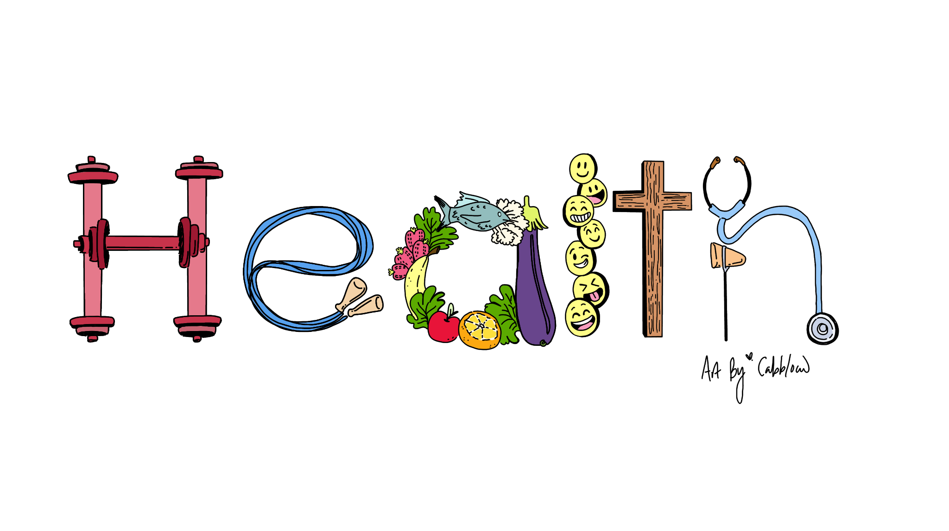

# **Health**

| [Benefits CheckUp](https://benefitscheckup.org/) | [GoodRx](https://www.goodrx.com/go/sem-prescriptions?utm_campaign=11601593411&utm_content=124506047475&utm_source=google&utm_medium=cpc&utm_term=kwd-1151452566&gclid=Cj0KCQjw06-oBhC6ARIsAGuzdw1FJFbh-BbS8FKPqpkUqJu6zYuEueWFmCqFe5jwTZSvlA39Evq3C6EaAtCSEALw_wcB&gclsrc=aw.ds) |
| --- | --- |
| [Columbus Ohio Alcohol and Drug Programs](https://www.columbus.gov/publichealth/programs/alcohol-and-drug-programs/) | [My Healthfinder](https://health.gov/myhealthfinder) |
| [Columbus Ohio Parks and Recreation](https://columbusrecparks.com/) | [National Institute for Mental Health](https://www.nimh.nih.gov/) |
| [Dental Clinic](https://new.columbus.gov/Services/Public-Health/Find-Healthcare-Resources/Dental-Clinic) | [StickK](https://www.stickk.com/) |
| [Digital Resources for Mental Health](https://socialworklicensemap.com/social-work-resources/mental-health-resources-list/) | [Substance Abuse and Mental Health Services Administration](https://www.samhsa.gov/) |
| [Eat Right](https://www.eatright.org/) | [WebMD](https://www.webmd.com/) |
| [Free Medical Clinic](https://new.columbus.gov/Services/Public-Health/Find-Healthcare-Resources/Free-Medical-Clinic) |  |

# **Research and News**

| [Academia](https://www.academia.edu/) | [JSTOR](https://www.jstor.org/) |
| --- | --- |
| [CNN](https://www.cnn.com/) | [Library of Congress](https://www.loc.gov/) |
| [Columbus Dispatch](https://www.dispatch.com/) | [MSNBC](https://www.msnbc.com/) |
| [ERIC (Education Resources Information Center)](https://eric.ed.gov/) | [USA Today](https://www.usatoday.com/) |
| [FOX News](https://www.foxnews.com/) | [U.S. News and World Report](https://www.usnews.com/) |
| [Google Scholar](https://scholar.google.com/) |  |

# **Shopping and eCommerce**

| [Safe Online Shopping Tutorial](https://edu.gcfglobal.org/en/internetsafety/safe-online-shopping/1/) | [Etsy](https://www.etsy.com/?utm_source=google&utm_medium=cpc&utm_term=etsy_e&utm_campaign=Search_US_Brand_GGL_ENG_General-Brand_Core_All_Exact&utm_ag=A1&utm_custom1=_k_Cj0KCQjw06-oBhC6ARIsAGuzdw3K_8mx3vs9EGIOQhVA99pKKcJJaTLyZfVYt_yXR7CV7gSP7n-PxbwaAq7tEALw_wcB_k_&utm_content=go_227553629_16342445429_536666953103_kwd-1818581752_c_&utm_custom2=227553629&gclid=Cj0KCQjw06-oBhC6ARIsAGuzdw3K_8mx3vs9EGIOQhVA99pKKcJJaTLyZfVYt_yXR7CV7gSP7n-PxbwaAq7tEALw_wcB) |
| --- | --- |
| [Amazon](https://www.amazon.com/) | [Honey](https://www.joinhoney.com/) |
| [eBay](https://www.ebay.com/) | [RetailMeNot](https://www.retailmenot.com/) |

# **Travel and Leisure**

| [AirBNB](https://www.airbnb.com/) | [Obtaining a Passport](https://travel.state.gov/content/travel/en/passports.html) |
| --- | --- |
| [Day Trips from Columbus](https://www.thefamilyvoyage.com/fun-day-trips-from-columbus-ohio/) | [Trip Advisor](https://www.tripadvisor.com/) |
| [Free Resources](https://www.youtube.com/watch?v=u8ObO3vKODE&t=3s) | [Trippy](https://www.trippy.com/) |
| [Google Flights](https://www.google.com/travel/flights) | [Uber](https://www.uber.com/) |
| [Hotels.com](https://www.hotels.com/) | [VRBO](https://www.vrbo.com/) |
| [Kayak](https://www.kayak.com/) | [WikiTravel](https://wikitravel.org/en/Main_Page) |
| [Lyft](https://www.lyft.com/) | [Yelp](https://www.yelp.com/) |